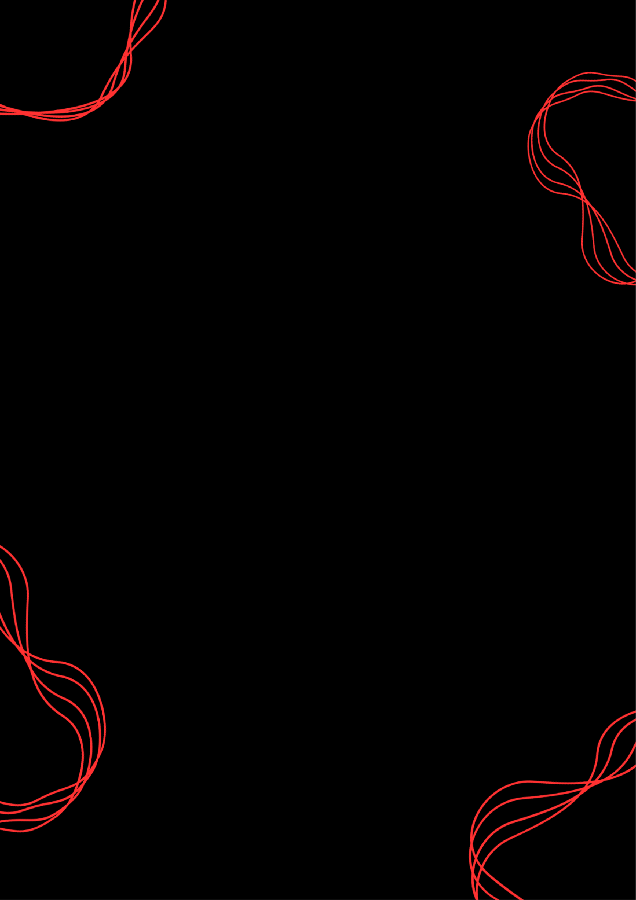

CHALLENGE NAME: [TENET]   
DEV: [YASH SWAMI]

CATEGORY: [STEGANOGRAPHY]   
LEVEL: [MEDIUM]

2025



CHALLENGE NAME: [TENET]

**Challenge Description**:   
  
"Two realities coexist: one moving forward, the other in reverse. Your past self has left you clues, but only by decrypting both timelines can you escape. Can you break free before the loop resets?" Search for the future  
  
**HINT:**"Use 256 to unlock, 512 to guide the way."

**Solution:**

On extracting the tar file given, we have a .wav file and a .jpg Doing exiftool on the jpg gives

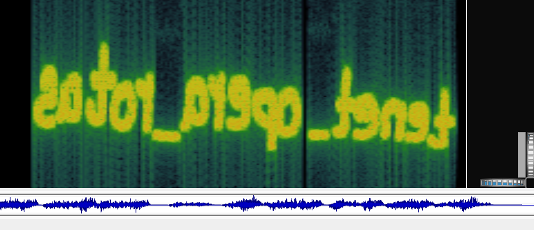  
  
  
 on opening wav file in sonic visualizer, in spectrogram we see  
  
  
 : this is pass if you try steghide on .jpeg  
 sator_arepo_tenet , you get latin.txt hidden in jpeg  
   
 now you have multiple hints to move forward in solving the question such as comment in .jpeg “I hold time in mirrored words…” or in question description "Two realities coexist: one moving forward, the other in reverse or you can OSINT and get this “the Sator square”

DEV: [YASH SWAMI] **1**

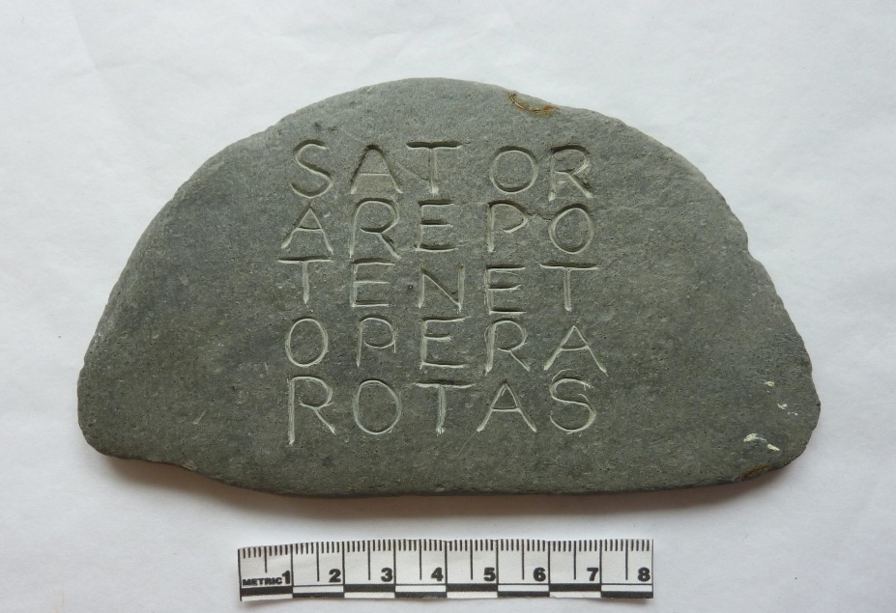

you had to figure out “tenet_opera_rotas”

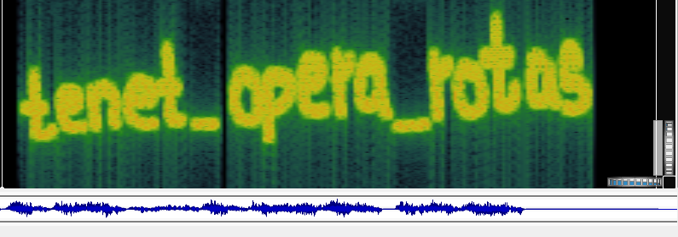  
 latin.txt is salted openssl encrypted and tenet_opera_rotas is passphrase  
   
 using command:  
 openssl enc -d -aes-256-cbc -base64 -pbkdf2 -md sha512 -in latin.txt -out flag.txt -pass pass:"tenet_opera_rotas”  
  
you get reversed flag:}D3N3PP4H_YDA3RLA_SAH_3RUTUF_3H7{GALF  
  
  
**FLAG:** FLAG{7H3_FUTUR3_HAS_ALR3ADY_H4PP3N3D}